News from
Heather Foundling-Hawker
www.hands-on.me.uk

HEATHER FOUNDLING-HAWKER TAKES THIRD PLACE IN 6DAY HUNGARIAN ROAD RACE
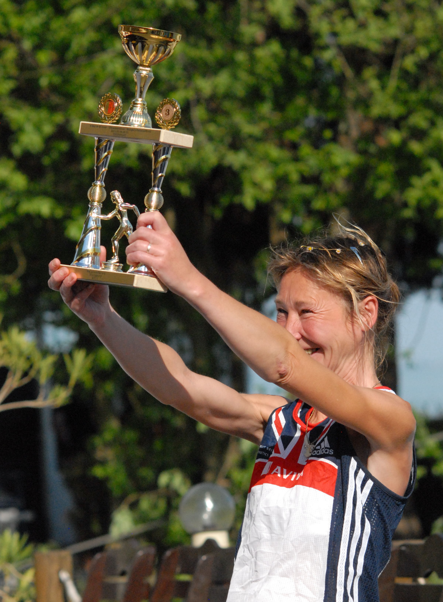 | Honiton based ultra distance athlete Heather Foundling-Hawker, 45, achieved a remarkable 3rd place in the inaugural Balatonfured 6 Day Road Race, which finished on Tuesday May 10th in western Hungary.  In her debut at this event, Heather covered 633.570kms (393.682miles). This is the equivalent of 2.5 marathons per day.  Temperature extremes challenged the 27 starters with bitterly cold night time temperatures contrasting with day time heat in the high 20’s C, and a short period of heavy rain tested the full range of Heather’s clothing, as well as her resolve.
“Courage surpasses freedom. Perseverance against adversities brings reward ”quote by Heather

An invitation to run in the Turin to Roma, ITALY was given to Heather after the race.

 | 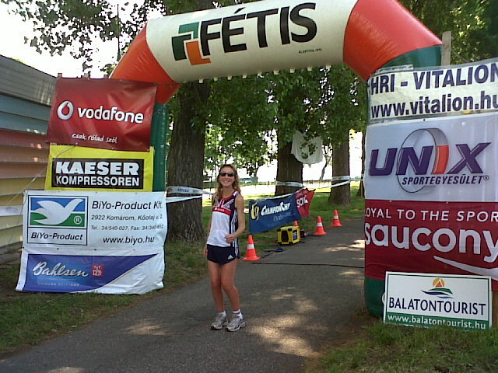 |  | 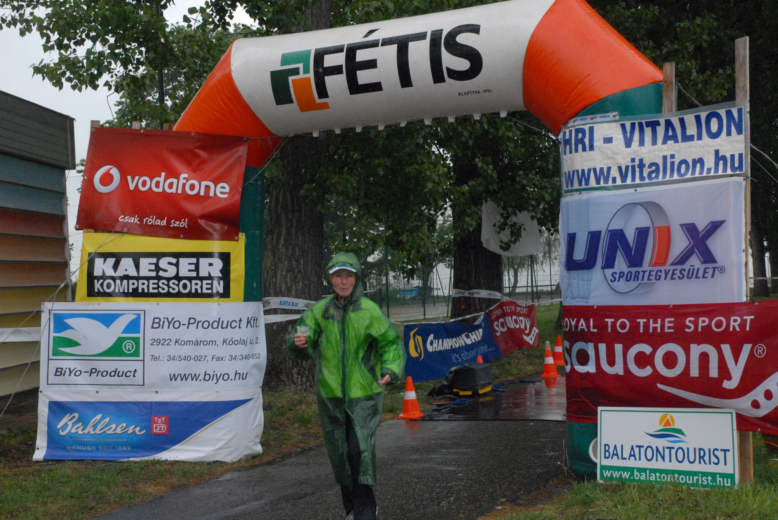

Heather is grateful to her sponsors:
C. J. Clark International Limited Trading, Profeet, Hilly Clothing
& the Local Round Table

